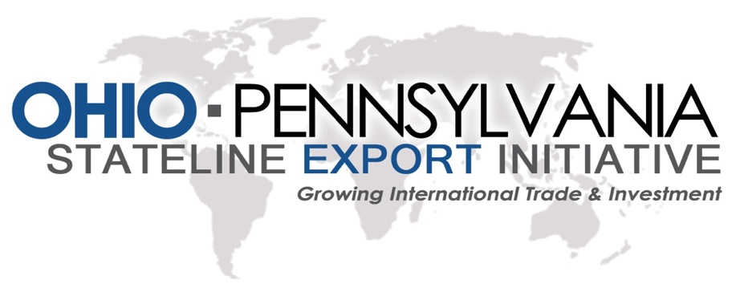

Ohio-PA Stateline Region
Export Initiative Survey

Company Information

Company Name

Address

City, State

Zip Code

County

Phone (000)-000-0000

Fax

Website

Contact name

Title

Contact Phone Number

Email

Number of Employees Number of employees involved in exporting?

Annual Sales Volume

Please Describe your company’s products and services. (Please use the key words of your industry, and names of specific products or processes.)

Exporting Activity

Describe your company’s exporting activity. (Exporting is defined as selling goods or services to a company, person, or to your company’s subsidiary or partner located in a foreign country. Please select all that apply.)
- Exporter of goods
- Exporter of services

What are the reasons your company does not export? Select all that apply.
- Product/service cannot be exported
- Enough business from state/local/regional market
- Operations (workforce, equipment, employment) already at capacity
- Lack of Financing
- More interested in expanding within the U.S.
- Don’t know what to do to export
- Other

Please specify the industries of your exported goods. Select all that apply.
- Agriculture
- Mining
- Chemicals
- Computers and electronics
- Electrical machinery
- Food
- Furniture
- Machinery
- Medical Devices
- Metals
- Petroleum, coal, and related products
- Plastics and Rubber
- Precision instruments
- Stone and Ores
- Textiles
- Transportation Equipment
- Waste and Scrap
- Other Manufacturing

- Other (non-manufacturing)

What industries does your company primarily serve? Select all that apply.
- HVAC
- Lumber
- Marine
- Material Handling
- Medical
- Mining
- Non-Manufacturing
- Paper
- Pharmaceutical
- Plastics
- Power Transmission
- Shale, Oil, Gas
- Steel
- Textiles
- Transportations
- Utilities
- Other

Food and Beverage Utilities
Government Other

- Aerospace
- Agriculture
- Automation and Machinery
- Automotive
- Business Equipment
- Chemicals
- Communications
- Construction
- Consumer Products
- Containers & Packaging
- Controls
- Defense (Non-Aerospace)
- Electronics
- Energy
- Fluid Power
- Food and Beverage
- Government

Does your company export a finished product? (Your company is not a distributor, supplier of intermediate input, etc.)

- Yes
- No

Please List and rank the top five products for your business. (Please include both the HTS and NAICS code if you know. For Reference the attached listing. Note: NAICS codes are required for government contracting as well as other business industry identification purposes. If you need help finding your NAICS codes, go to: https://www.naics.com/search)

 | Product Name | HTS code | NAICS code | Description
Product #1
Product #2
Product #3
Product #4
Product #5

What are the top 5 export markets (countries) and the percentage of total export sales?

 | Country | % of Export Sales
Country #1
Country #2
Country #3
Country #4
Country #5

What are the main reasons your company exports to these countries? Select all that apply.

- Direct Sales (exports) opportunities
- Company or contact in foreign country selected my company
- Prior relationship or previous experience with companies or contacts in these countries
- Distributors in these countries
- Established partnership with foreign company in these countries
- English language market
- Proximity to the U.S.
- Similar business environment to the U.S.
- Stable political/economic environment
- Other

What was the value of your company’s exports in 2017?
- Less than $50,000
- $50,001 - $250,000
- $250,001 - $1,000,000
- $1,000,000 - $10,000,000
- Over $ 10,000,000

Exports account for what percentage of your company’s total sales?
- 26% - 30%
- 31% - 50%
- Over %50
- Uncertain

- 0% - %5
- 6% - 10%
- 11% - 15%
- 16%-20%
- 21-25%

Does your firm have plans to export into a new country?
- Yes
- Possibly within the next five years
- No
- Not Sure

Please List new markets you plan to export to:

Country # 1:

Country # 2:

Country # 3:

What are the FIVE most significant challenges faced by your company when exporting or considering new export markets? Select up to five.

- Global advertising, marketing, distribution
- Transportation Cost
- U.S. Export laws, regulatory compliance, licensing, inspections, tariffs
- Difficulty in obtaining U.S. entrance visas for visitors
- Protection of intellectual property rights
- Foreign import control laws, regulatory compliance, inspections, tariffs
- Foreign government regulations/policies
- Foreign government support programs
- Exchange rate fluctuations
- Customs Clearance
- Language and Cultural barriers
- Knowledge of foreign markets
- Small scale production (general operations)
- Working Capital financing (general operations)
- Other, please specify

Does your company currently have locations outside the united states? (such as overseas subsidiaries, distribution centers, sales offices, etc.)

- Yes
- No
- Uncertain

Have you received any export-related assistance from government or non-profit providers?

- Yes
- No
- Uncertain

Which organizations have you consulted? Select all that apply.

- State-level agency focused on trade or export development (such as Ohio Export Assistance Network or PA office of International Business Development, or a Small Business Development Center)
- Non-Profit association or organization focused on trade or international business issues
- Small Business Administration (SBA)
- U.S. Commercial Service
- Government export financing agency (i.e. Ex-Im Bank)
- Procurement Technical Assistance Center (Government Contracting)
- Other

How could federal/state/local government help your company begin exporting, increase exports, or expand to new country markets?

Transportation

Please select the following that describes your manufacturing business.

- OEM
- Tier Supplier
- Proprietary Products
- Custom or Contract Manufacturing

Which mode of transportation do you use most frequently? Select all that apply.

- Rail
- Truck
- Ship
- Air

What Challenges is your company currently facing with transportation?

What percent of product revenue goes towards shipping costs?

- 1-5%
- 5-10%
- 10-25%
- Over 50%
- Uncertain
- Customer Pays Costs

Please List your top three Primary Freight-Forwarders?

Freight Forwarder #1:

Freight Forwarder #2:

Freight Forwarder #3:
Macroeconomic Issues

How have the recent tariff changes effected the following: (Please add specifics in regards to your gains or losses in sales and overall profits, and any effect that the tariffs have had to your overall procurement prices.)

- Procurement Prices

- Profit +/-

- Sales +/-

How has the new corporate tax cut affected your business on the following items? (Please add specifics in regards to your gains or losses in the following categories profits, sales, wages to employees, and company bonuses to employees.)

- Profits +/-

- Sales +/-

- Wages +/-

- Bonus to employees +/-

Is your company currently: (Looking at growth, please inform us if your company is spending on new equipment or plant expansion? Please feel free to add any relevant detail to this information in the text box provided.)

- Spending on new equipment

- Spending on plant expansion

How difficult has it been to attract new, qualified employees?

- Extremely difficult
- Somewhat difficult
- Neither easy nor difficult
- Somewhat easy
- Extremely easy
Please explain the answer above, and what steps taken to attract new employees.

Would your company be interested in attending a trade mission? If so, what country would be best for your future goals?

What other challenges is your company currently facing that you would like us to be aware of?

